**LAB EXPERIMENTS**

**Experiment 1:**

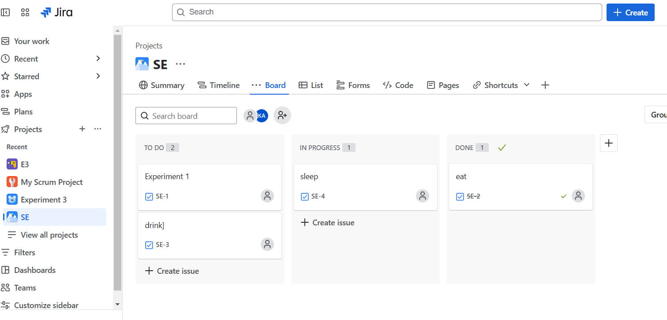

**Experiment 3**:

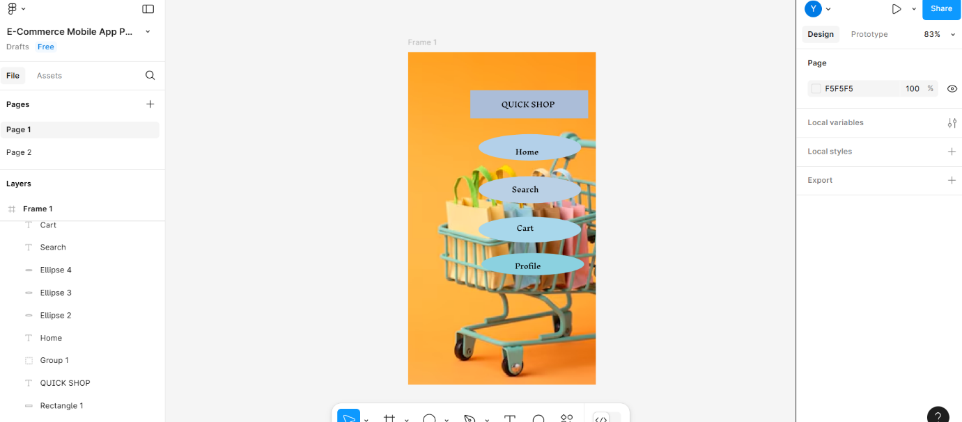

**Experiment 4:**

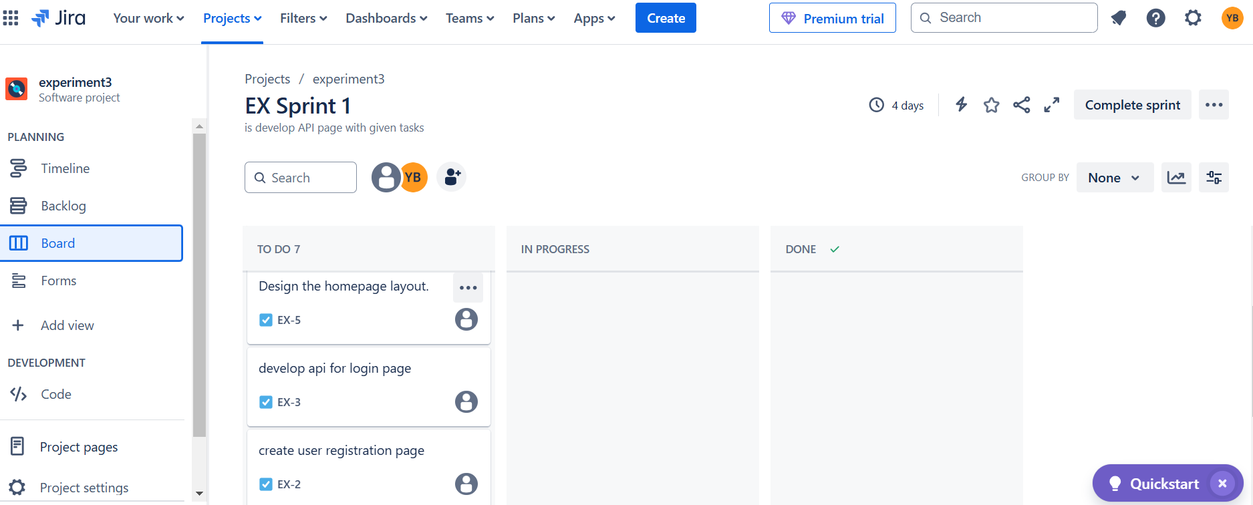

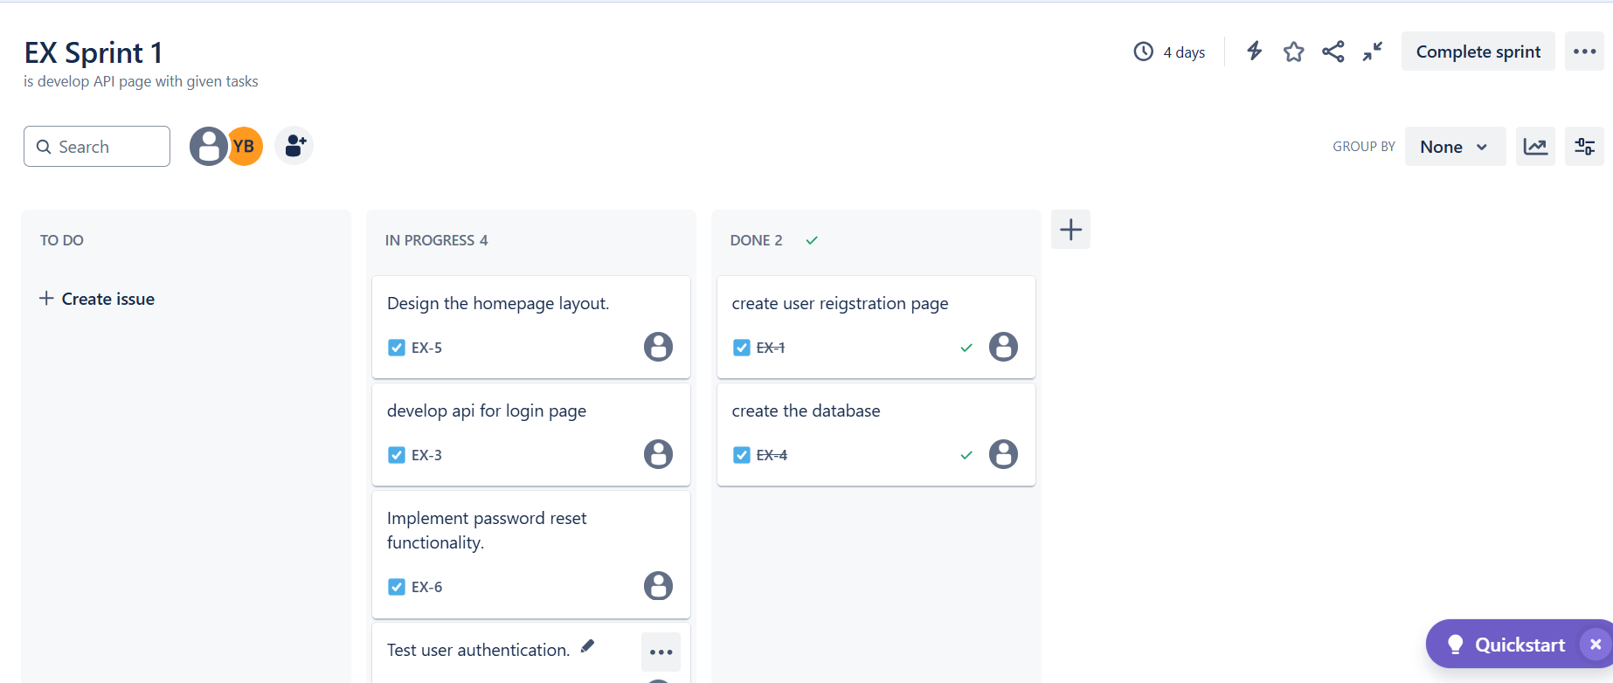

**Experiment 5:**

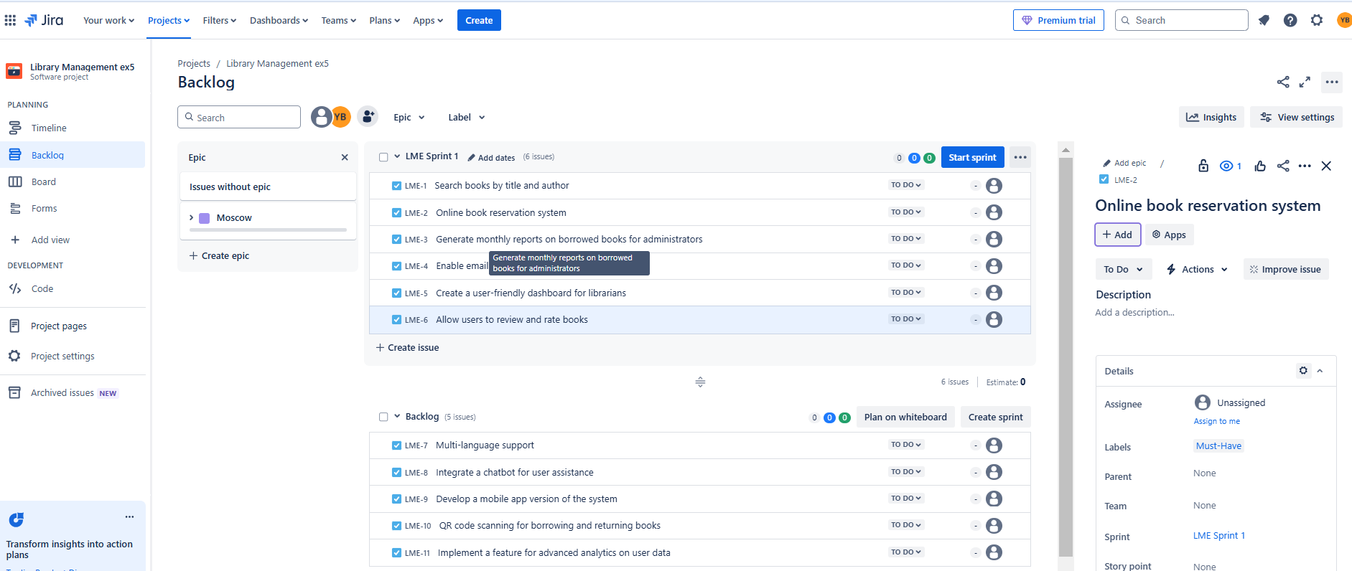

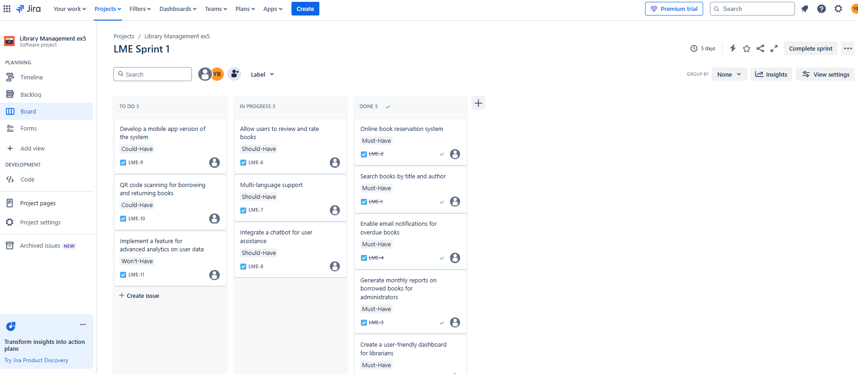

**Experiment 6:**

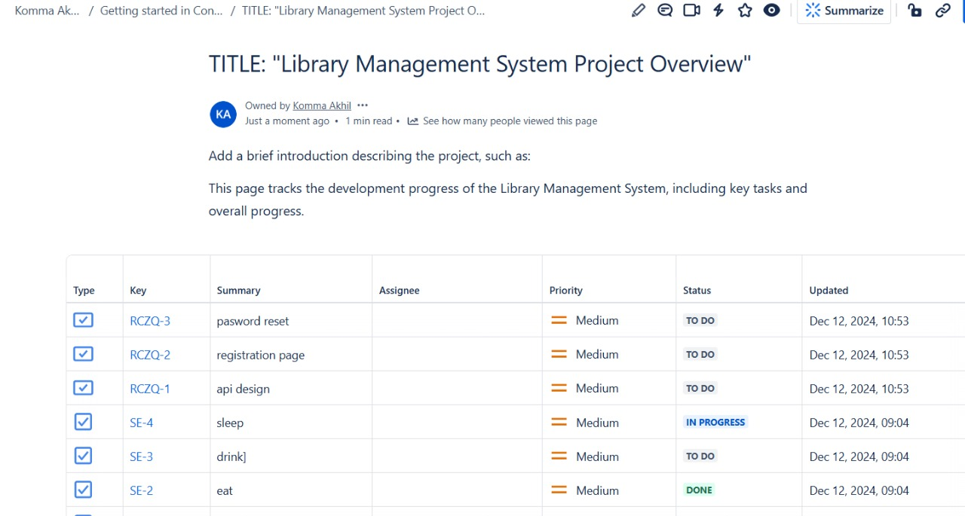

**Experiment 2:**

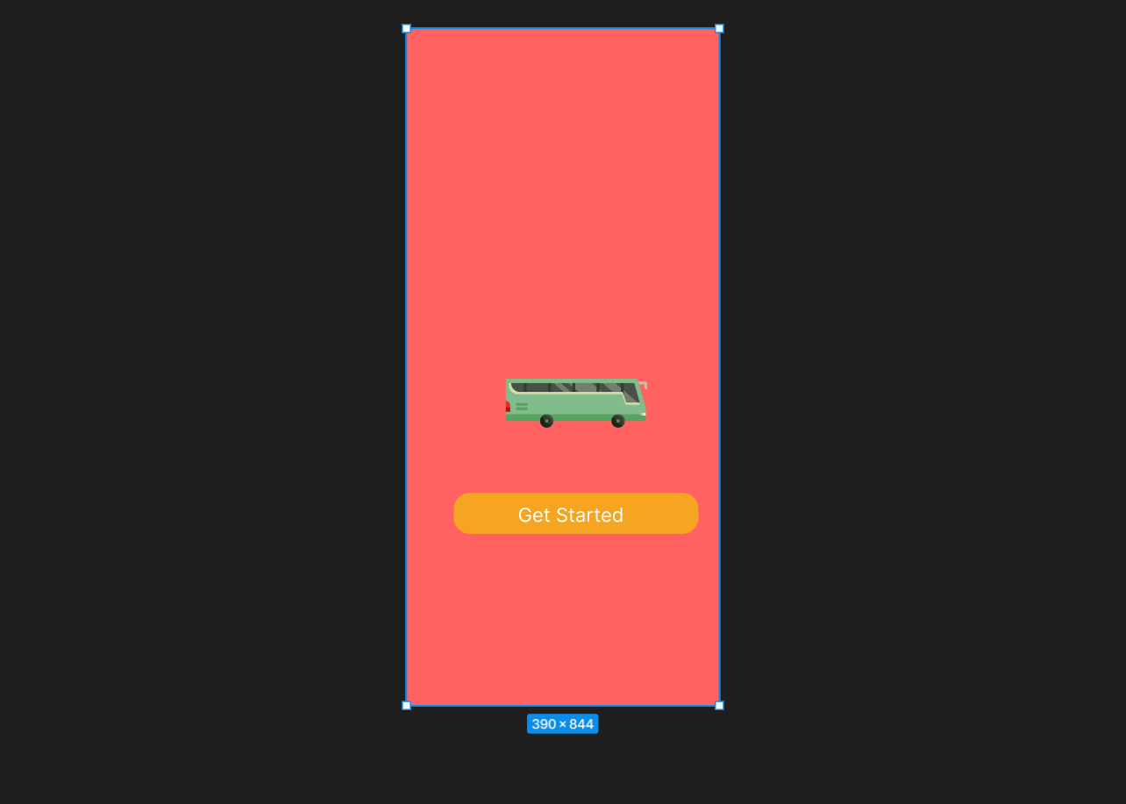

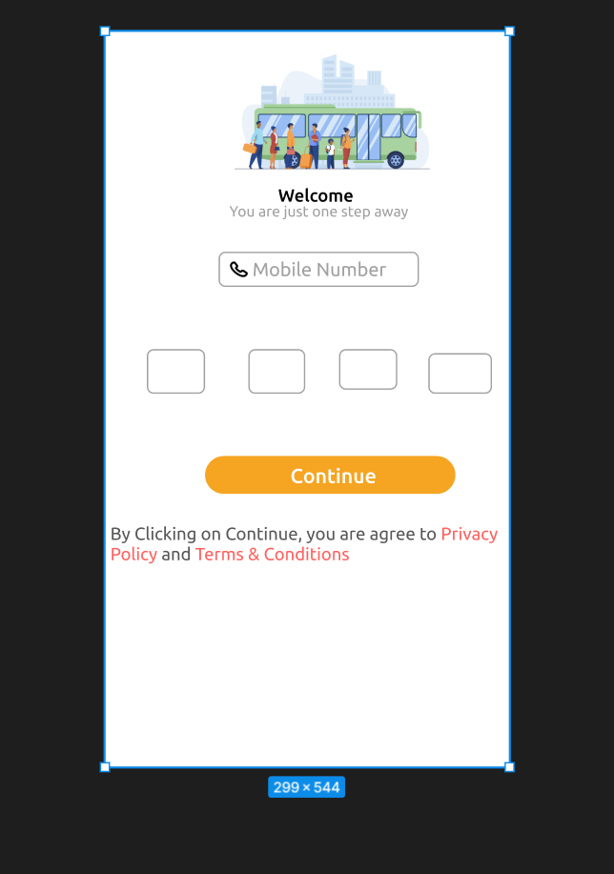

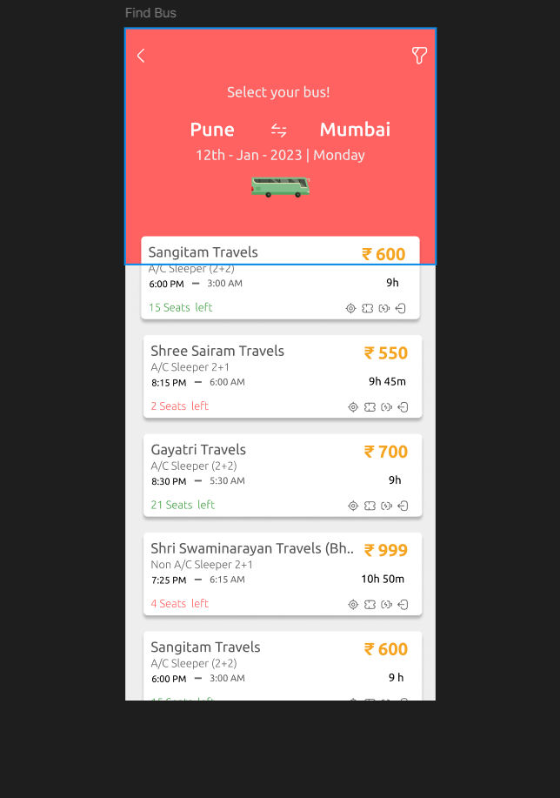

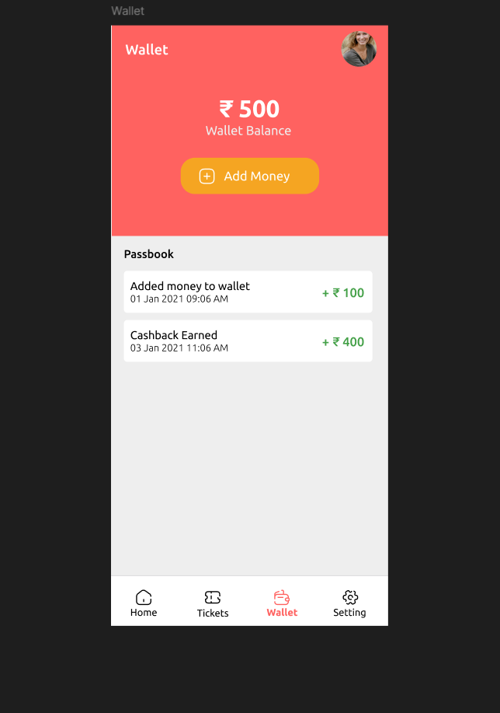

**Experiment 7**

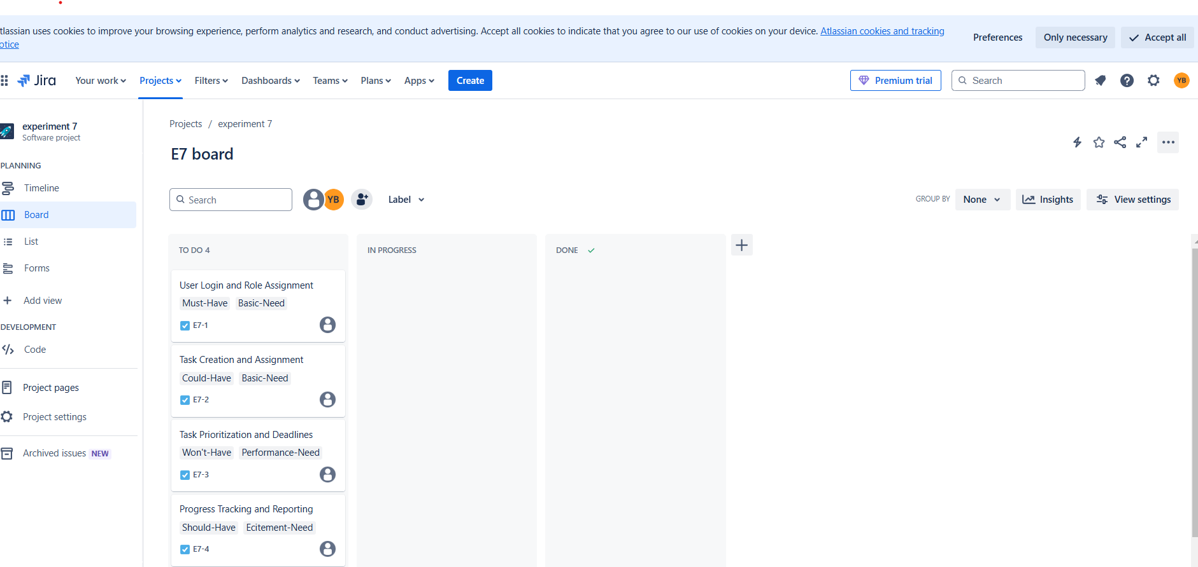

**Experiment 8**

**Experiment 11**

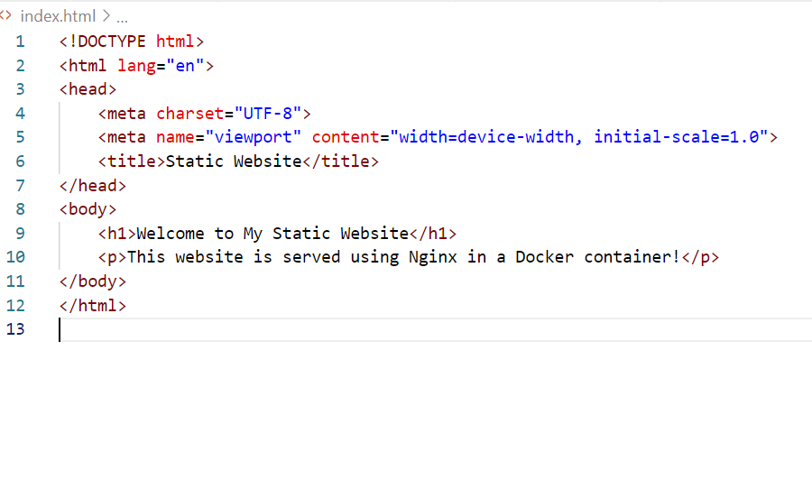

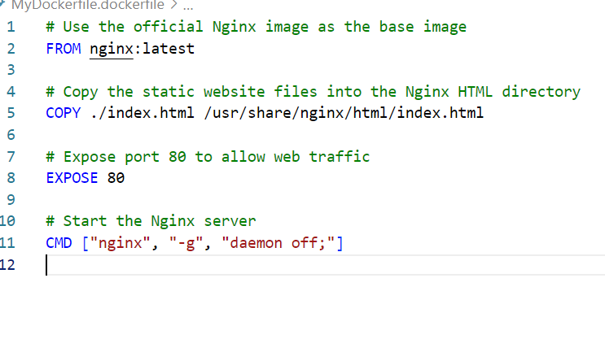

**Example 14**

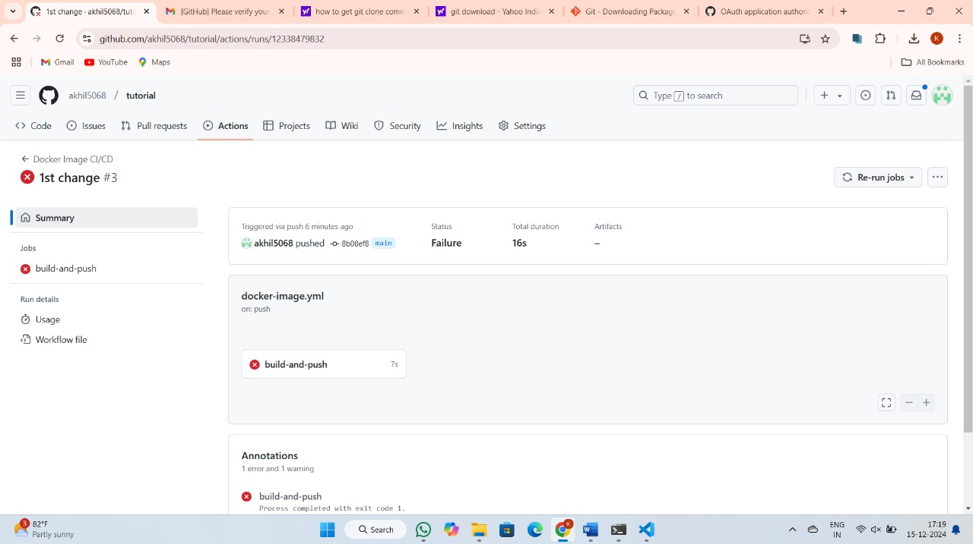

**Example 17**

